**ALMUBARAK ISLAMIC NURSERY, PRIMARY AND SECONDARY SCHOOL**

**P.O.BOX 1614 ZANZIBAR PHONE: 0777423080 OR 0773326600 *Almubarak.web44.net***

**(NYUMBA MBILI ROAD) MWANAKWEREKWE ZANZIBAR**

**HOME PACKERGE SCIENCE AND TECHNOLOGY   
GRADE FOUR**

**1** .Fill in the blanks by choosing the correct word in the box

(i) An organ where gaseous exchange takes place__________________

(ii)The solid state of water___________________________________

(iii) Attract insects for pollination_____________________________

(iv) A good source of vitamins in the diet_______________________

(v) Bending of light rays ____________________________________

|  |
| --- |
| refraction, water vapour, petals, heart, sun, ice, vegetables, nose, cassava, reflection and lungs |

2. Makame is sick, he has the following symptoms:

•Has a protruding stomach and swelling legs.

• His skin is dry and rough.

• His hair is reddish and falls out easily.

• Has no appetite.

(i) Name the disease that the boy is suffering from__________________

(ii) What is the cause of that disease?  
(iii) Suggest the type of food that should be given to help him

3. These are two communication devices.

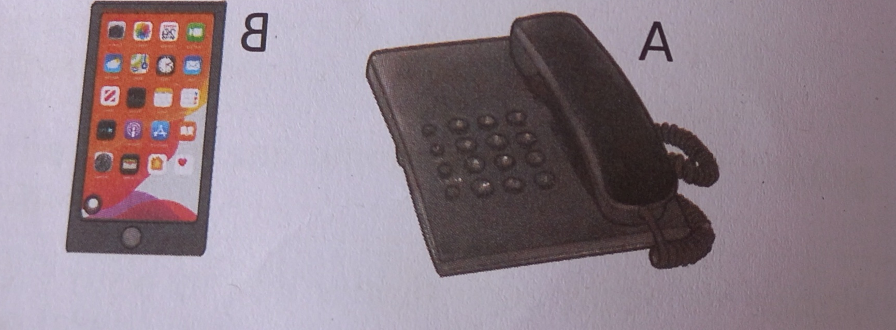

(i) Give their names.  
 A:_______________________________________________________  
 B:_______________________________________________________

(ii) List down two (2) differences between them.  
4. Mwanamwema is washing her clothes but the water does not form lather easily.

A. What type of water has she used? __________________________

B. List two (2) sources of that water___________ and ___________

C. What are two (2) disadvantages of that water? _____________ and____________

5. A. What is light?  
B. Classify the following source of light in the table below;  
 torch, sun, bulb, star, lamp, fireflies and candles wax.

C. Mention two (2) characteristics of light.

6. A. Insects have three main body parts

B. Mention five (5) examples of insects.  
C. Insects are very useful organisms for human beings. Mention three (3) advantages of insects.

6a. List down three (3) components of soil.  
 b. Write down three (3) uses of soil.

c. The table below shows the characteristics of soil. From each characteristic identify the type of soil.

|  |  |
| --- | --- |
| Soil characteristic | Type of soil |
| i) The type of soil which has low water holding capacity. |  |
| (ii) The type of soil which has poor air supply |  |
| (iii) The type of soil which is the best for farming |  |